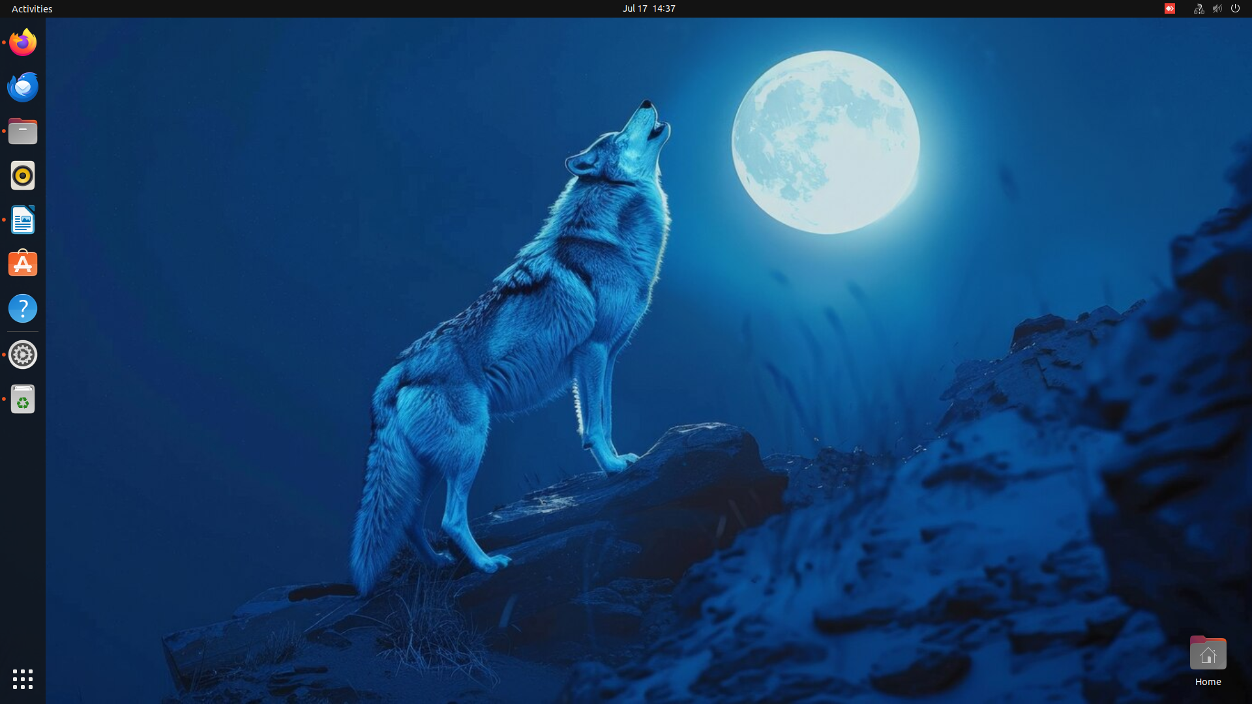
iii)DESKTOP BACKGROUND

iv)LIST OF THE INFORMATION IN MY NETWORK SETTINGS
1)Wired
2)VPN
3)Network proxy

v)PRE INSTALLED SOFTWARES
1) Additional softwares-where we can add additional softwares for using.
2) Aisleriot solitaire-its a card game.
3) Anydesk-Its more like screen sharting with the access to your screen and using yours .
4) Brave web browser-this web browser is mainly used for apps that can easily eliminate adds .
5) videos-supports videos to watch.
6) Calendar-to check the dates,months and also year.
7) Calculator-to make calculations.
8) Text editor-it ismlike a notepad.
9) DB browser for SQ lite-I think it is for creating a new software type datas.
10) Document scanner-To sacn the important documents.
11) Docker desktop-Docker Desktop is free for small businesses (fewer than 250 employees AND less than $10 million in annual revenue), personal use, education, and non-commercial open source projects. Otherwise, it requires a paid subscription for professional use. Paid subscriptions are also required for government entities.
12) System monitor-to check how much space taken.
13) Fastqc quality control-to check the sequence file.
14) Terminal-to write code .
15) Htop – it is almost connected to terminal.
16) utilities-various types which is used for utilities are available in this.
17)Javamorph-maybe to work on java.
18) Language Support. – Helps you change the language and add keyboard layouts.
19) LibreOffice. – A free office suite, like Microsoft Office.
20) Cheese– Takes pictures and videos with your webcam.
21) LibreOffice Calc– A spreadsheet tool, like Excel.
22) LibreOffice Draw– For making diagrams and drawings.
23) LibreOffice Impress– For making presentations, like PowerPoint.
24) LibreOffice Math– Lets you write math formulas.
25) Mahjongg– A matching tile game.
26) MEGA– A cloud storage app to save files online.
27) Mines– A puzzle game where you avoid hidden mines.
28) Power Statistics- Shows battery and power usage info.
29) Oracle VM VirtualBox– Lets you run other operating systems on your computer.
30) R – A programming language used for statistics and data analysis.
31) Remmina – Lets you control other computers remotely.
32) RStudio– A program to write and run R code more easily.
33) Settings– Lets you change things on your computer (like Wi-Fi, sound, etc.).
34) Shotwell– Organizes and views your photos.
35) Software & Updates– Manages apps and system updates.
36) Software Updater– Checks for and installs system updates.
37) Startup Applications – Lets you choose which apps start when you turn on your computer.
38) Startup Disk Creator– Helps you make a bootable USB (to install Ubuntu, for example).
39) Sudoku– A number puzzle game.
40) Synaptic Package Manager – Advanced app installer and updater.
41) To Do– A simple task list app.
42) Transmission.– Downloads files using torrents.
43) Visual Studio Code– A code editor for programming.
44) UCSF ChimeraX 1.7.1. – Used to look at 3D structures of molecules and proteins.
45) X11VNC Server – Lets others see or control your computer remotely.
vi)TERMINAL in favourites
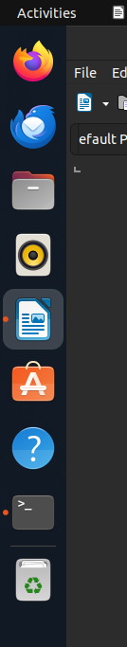

2)GITHUB ACCOUNT


3)LEARNING ABOUT THE KERNEL

i)
hostname - IBAB-Msc-BDB-Comp07
build number – 6.8.60-generic
SMP(symmetric multi processing)-PRREEMPT_DYNAMIC
Build time – Tue Apr 22 19:00:15
Machine hardware name – UTC 2 x86_64 x86_64
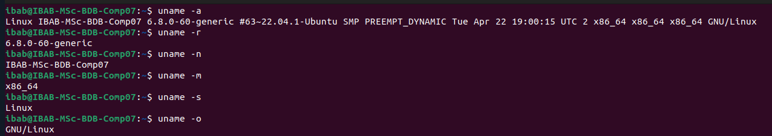
Operating system - GNU/LINUX

ii)
output for the commands uname -r ,uname -n, unamme -s, uname -o
